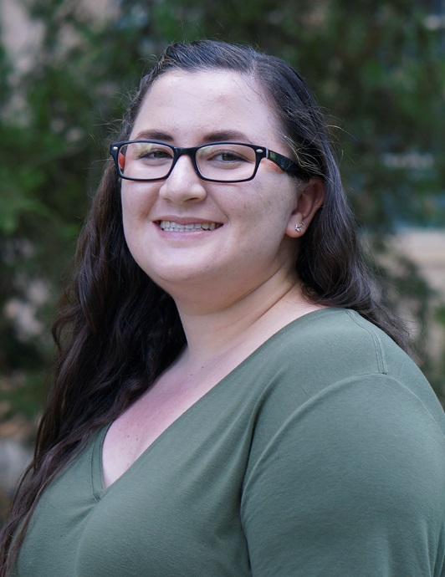

Gwynn Robertson
Winter 2018

Computer Room Consultant
of the Quarter
Wellman/SciLab

 | Daniel Lanci  Fall 2017 |  | Vang Xiong  Spring 2017 |  | Micah Germano  Winter 2017
 | Teresa Datar  Fall 2016 |  | Andie Tonnu  Spring 2016 |  | Andie Tonnu  Winter 2016
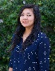 | Ling Yee Wong  Fall 2015 |  | Keke Orozco-Carpenter  Spring 2015 |  | Ling Yee Wong  Winter 2015

Computer Lab Management
IET-Academic Technology Services

